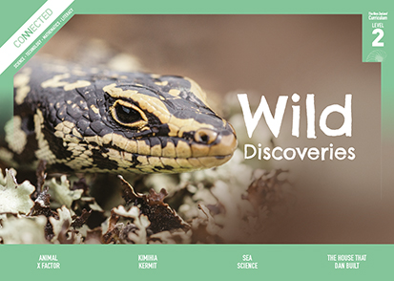
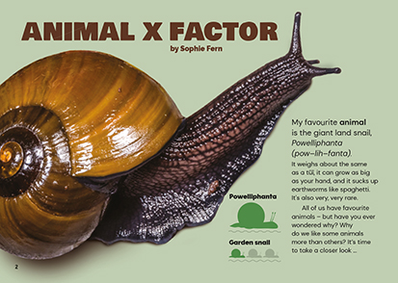
Connected
Level 2
2019

Animal X Factor
by Sophie Fern

The Literacy Learning Progressions: Meeting the Reading and Writing Demands of the Curriculum describe the literacy-related knowledge, skills, and attitudes that students need to draw on to meet the demands of the curriculum.
The Learning Progression Frameworks (LPF) describe significant signposts in reading and writing as students develop and apply their literacy knowledge and skills with increasing expertise from school entry to the end of year 10.

Overview
The article explores familiar questions – why do we like some animals more than others, and does it matter? – but encourages the reader to look at it from a more critical, scientific perspective.
A Google Slides version of this article is available at www.connected.tki.org.nz
Curriculum contexts

SCIENCE: Nature of Science: Participating and contributing  Level 2 – Students will explore and act on issues and questions that link their science learning to their daily living.  SCIENCE: Living World: Evolution  Level 2 – Students will recognise that there are lots of different living things in the world and that they can be grouped in different ways. | Key science ideas  - Scientists have agreed on one way of grouping animals into subgroups, such as insects, fish, amphibians, reptiles, birds, and mammals.  - The animals within each group share a set of key features.  - We can often tell what group an animal belongs to just by looking at its features.  - We need to observe carefully in order to group animals that have similar features.  - Living things that may not appeal to us are still important to the balance of their ecosystems.
ENGLISH: Reading  Level 2 – Ideas: Students will show some understanding of ideas within, across, and beyond texts. | Indicators:  - uses their personal experience and world and literacy knowledge to make meaning from texts  - makes meaning of increasingly complex texts by identifying main ideas  - makes and supports inferences from texts with some independence.

The New Zealand Curriculum

Meeting the literacy challenges
The instructional strategies below support students to meet the literacy challenges of this text. For each strategy, there are links to the relevant aspect of The Learning Progression Frameworks (Reading). The signposts on each of these aspects provide detailed illustrations on what to notice as your students develop their literacy knowledge and skills for different purposes in different curriculum areas.

The main literacy demands of this text require students to critically reflect on why they like some animals more than others. The text scaffolds them through a straightforward structure and a focus on a familiar and engaging topic.  The article is based around two questions found on the first page: Why do we like some animals more than others? and Does it matter? Some answers to those questions are then explored in subsequent sections. Students are supported with headings based around common, easily recognisable animal characteristics as they look for specific information.  Technical language and topic-specific vocabulary are supported by a glossary and through practical examples and engaging photographs. Examples include the names of different species or places.  The text also includes some rhetorical questions to help the reader make personal connections to the text. The article alludes to some other complicated scientific ideas, such as evolution and ecosystems, but doesn’t go into detail. | Most sentences and paragraphs are quite short. A few longer sentences could be a challenge but will help students to make connections between different ideas (for example, “People tend to like creatures that are distinctive [stand out from the crowd], so when we see them, we know what they are”).  The following strategies will support students to understand, respond to, and think critically about the information and ideas in the text.  You may wish to use shared or guided reading, or a mixture of both approaches, depending on the reading expertise of your students and the background knowledge they bring to the text.  After reading the text, support students to explore the activities outlined in the following pages.

INSTRUCTIONAL STRATEGIES

Finding the main ideas  [LPF Reading: Acquiring and using information and ideas in informational text]  Have the students look at the photograph and read the title on page 2. PROMPT them to make connections to predict what this text will be about and begin thinking about the main idea. Remind them that we can use images and our prior knowledge (for example, from television) to make predictions.  Where have you heard the term “X Factor”? What does it mean? What do you think this article will be about?  You all had different responses to the snail. Some of you said it’s slimy, and others said it’s beautiful! Why the difference?  Have the students read the introductory text and DISCUSS with each other which animals they like best and which animals are their least favourite. ASK the students to explain why they like some animals more than others.  RECORD the students’ ideas on the whiteboard. EXPLAIN that the writer goes on to explore possible answers to her questions. Tell the students to focus on the headings and photographs, using them to predict what the answers may be. Create a summary chart and RECORD the headings, the students’ predictions, and single-sentence statements, summarising what the writer actually says. | Question: Why do we like some animals more than others?  Heading We predict … We found …  Media attention  Size  Colour  Distinctiveness  Cuteness  Question: Does it matter?  Why does it matter?  Adored – not ignored  PROMPT the students to notice that there are further questions within the text. EXPLAIN that the writer has included these to help us think more about our own thoughts and feelings. Encourage the students to discuss their responses to the questions with a buddy as they read.  PROMPT the students to think critically about the author’s message.  Why do you think the author wrote this text?  Has your thinking changed since you started reading?

Meeting the literacy challenges

Dealing with unfamiliar vocabulary  [LPF Reading: Making sense of text: vocabulary knowledge]  PROMPT the students to identify the topic-specific vocabulary.  DISCUSS the meanings of these words, prompting the students to use:  - their prior knowledge  - the explanations in the text  - contextual information  - the glossary  - the photographs and their captions.  Have the students create simple definitions of some of the key terms. They may need to do some further research. The students could record their definitions on a graphic organiser like the one below.  Term Information Picture Sentence  word 1  word 2 | PROMPT the students to notice the two different names for the giant land snail. EXPLAIN that Powelliphanta is named after Dr A. Powell, a former scientist at Auckland Museum who studied the snails during the 1930s and 1940s. Add that animals are often named after people, but not always. Sometimes they are named after what they look like, how they behave, or where they are from.  Look back at the photographs. Can you find examples of animal names based on their features?  Some of the animals also have names in te reo Māori. Do you think those names might also tell us about an important characteristic of these animals?  Note that this activity could lead to further investigation into how animals are named and how they are classified.

The Learning Progression Frameworks
The Literacy Learning Progressions
Effective Literacy Practice: Years 1–4

Illustrating the key ideas

We need to observe carefully in order to group animals that have similar features.  The animals within each group share a set of key features.  We can often tell what group an animal belongs to just by looking at its features. | 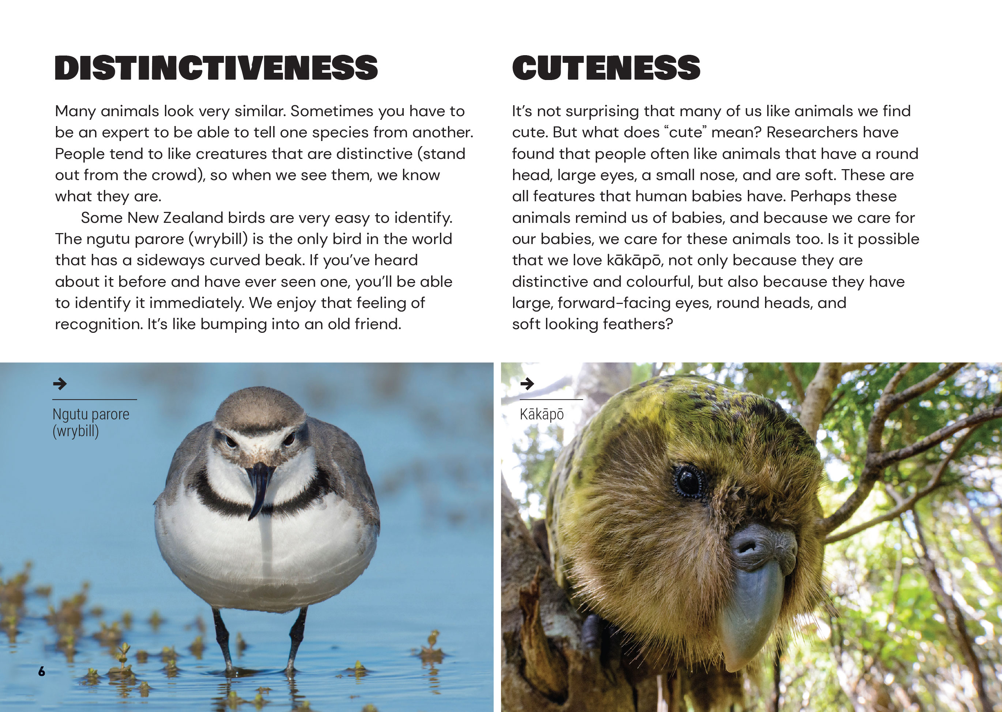
Living things that may not appeal to us are still important to the balance of their ecosystems.  We can often tell what group an animal belongs to just by looking at its features. | 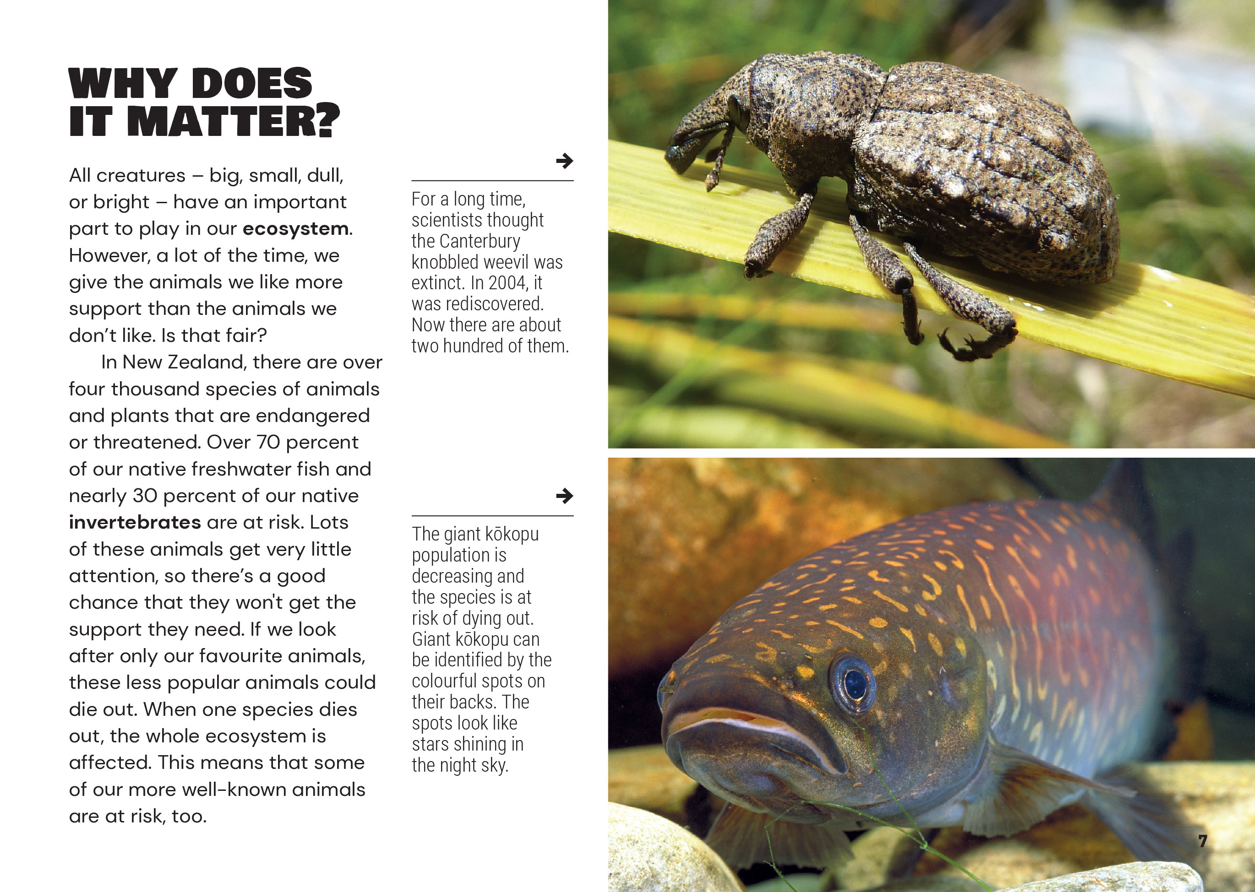

Learning activities – Exploring the science
The following activities and suggestions are designed as a guide for supporting students to explore and extend their content knowledge across the learning areas. Adapt these activities to support your students’ interests and learning needs.

Activity 1 – Media matters  As a class, reread the section on media attention.  How do you learn about animals? Where do you learn about them?  Ask students for examples of animals they have seen in the media. Prompt them to think about what appeals to people and how this affects how we think about different animals.  Point out that conservation groups deliberately use the media to raise awareness of the plight of different species. There will be local groups that you or the students will be familiar with.  What are some campaigns to raise awareness of endangered animals in New Zealand?  How do conservation groups use the media to promote their cause?  What about our own community? Are there people campaigning to protect animals here? What do we know about them? What are their concerns, and how they are trying to communicate them?  Construct a chart showing:  - examples of animals in the media (newspapers, magazines, television programmes, online campaigns)  - the purpose of this media attention  - an explanation of how the media seeks to engage our attention.  The students could investigate particular examples in small groups. The information could be shared on an online document so that it can be referred to later. Prompt discussion about the inferences that can be drawn from this investigation.  Look at the animals most often in the media. Do they have the characteristics of animals described as being popular in the article?  Why does the media pays attention to different animals?  What are some of the ways the media gets us interested in the animals?  If you wanted to bring attention to a particular animal through the media, how would you do it?  Extending the learning  Have the students work in groups to research a rare species, then design a publicity campaign to promote awareness of that species. They might create videos, posters, blog posts or items for the school newsletter, speak at assembly, or put on a dramatic performance. They could use their statistical skills to evaluate the impact of their campaign. | Activity 2 – Exploring ecosystems  Check that the students understand the concept of an ecosystem.  Think about our school playing field, local river, or park. What animals and plants are part of the ecosystem there? How are they connected?  Prompt the students to understand that we are part of the ecosystem, too. We are affected by other creatures and we have an impact on them.  What did you eat today? Where did that come from? What would happen if we lost all our potatoes to a pest or a disease?  Look at what you’re wearing. What are your clothes made from? Where did those materials come from?  Extend the students’ understanding of an ecosystem by using one of the activities from the Science Learning Hub or the Minecraft resource in which a typical ecosystem is disrupted due to an extinction.  Have the students research a favourite animal and find out about other animals in its ecosystem and the roles they play.  How would your favourite animal be affected if one of the other animals in this ecosystem was struggling to survive?  What might happen if some features of the non-living environment were changed? For example, what if a new housing development removed a lot of vegetation or caused pollution?  Have the students share what they learned in writing or they could create diagrams or models that show the ecosystem inhabited by the animal they chose. Then go back to the big idea in the article.  Sophie Fern told us that “All creatures – big, small, dull, or bright – have an important part to play in our ecosystem.” Do you agree? How would you explain this to someone who doesn’t know about ecosystems?  Extending the learning  The students could take on kaitiaki roles for an at-risk species from within the local ecosystem. This could involve working in partnership with a community organisation.

RESOURCE LINKS

Connected and School Journal  “Pet Power”, Connected 2017, Level 3, Mahi Tahi  “Wild Orphans”, Junior Journal 41, Level 2, 2010  “Ugly”, School Journal, Level 2, November 2014  Science Learning Hub  Conservation rankings: https://www.sciencelearn.org.nz/resources/1379-conservation-rankings  Freshwater ecosystem: https://www.sciencelearn.org.nz/resources/2591-freshwater-ecosystem  New Zealand bush ecosystems: https://www.sciencelearn.org.nz/resources/1173-new-zealand-bush-ecosystems  World Atlas  Who are the charismatic megafauna of the world? https://www.worldatlas.com/articles/who-are-the-charismatic-megafauna-of-the-world.html  What is an umbrella species? https://www.worldatlas.com/articles/what-is-an-umbrella-species.html  YouTube  Umbrella species: Ecological importance of umbrella species (3:01): https://www.youtube.com/watch?v=HfdOpf1L6Sk  Umbrella species and flagship species (0:38): https://www.youtube.com/watch?v=bncp-h30Iek | Media  Radio New Zealand: Critter of the Week: https://www.rnz.co.nz/national/programmes/afternoons/collections/critter-of-the-week  Heihei: Fanimals: https://www.heihei.nz/config/browse/screen/video-content/collection/details?cid=4797  Bird of the Year: https://www.birdoftheyear.org.nz/  KiwiKids News: Animals: https://kiwikidsnews.co.nz/category/animals/  Other sources  IUCN (International Union for Conservation of Nature) Red List of Threatened Species: https://www.iucn.org/resources/conservation-tools/iucn-red-list-threatened-species  Sciblogs: Charisma in nature (Sophie Fern): https://sciblogs.co.nz/guestwork/2018/10/01/charisma-in-nature/  How Stuff Works: How charismatic megafauna work: https://animals.howstuffworks.com/endangered-species/charismatic-megafauna.htm  Department of Conservation: Powelliphanta snail: https://www.doc.govt.nz/nature/native-animals/invertebrates/powelliphanta-snails/  Forest and Bird Society: https://www.forestandbird.org.nz/  Minecraft: Loss of biodiversity: https://education.minecraft.net/lessons/loss-of-biodiversity/

Learning activities – Exploring technology
and mathematics and statistics

Activity 1 – Is it true?  Review the summary chart created during reading and discuss why people tend to prefer some animals over others. Support the students to design a survey of people at school or in the wider community to find out whether the claims are correct. They could do this on paper or digitally. Possible digital tools include Excel, Google Forms, Survey Monkey, and Qualtrics.  The nzmaths unit “My Favourite” suggests different ways to collect and display data. However, note that the students want to find out what makes certain animals more likeable than others, so that adds complexity to their investigation.  What is our problem? What exactly do we want to find out? How can we state that as a question?  How will we get the information we need to find the answer to our question? Who will we ask?  How many people do you think we need to ask to get a valid answer?  How will we record our data? How can we organise it so that we can work out what it means?  What does our data show? How do our findings compare with Sophie Fern’s statements about why people prefer some animals over others?  Are there other possible explanations for our data?  Are there people who should know about our findings? How could we communicate them? | Remind the students that Sophie Fern claims that our preferences endanger the lives of less popular animals. Prompt the students to do a second investigation where they might compare their survey results with information about endangered species.  Sophie says that we give more support to the animals we like. When we look at our survey results, is that true? How could we test her claim?  Sophie also says that well-known animals are put at risk when other animals in their ecosystem are wiped out. Can you find evidence for this?  Extending the learning  This activity could be the stimulus for local environmental action, as suggested in Activity 1. They could use data and statistics to investigate the success of their campaign or to compare their findings and conclusions with those of other, similar surveys. They could then ask “Does it matter?”  What have some other people concluded from their surveys of preferred (or charismatic) animals?  What things have happened because of this?  What are some other ways people use statistics to learn about our environment and ways to protect it?  The following activities and suggestions are designed as a guide for supporting students to explore and extend student content knowledge across the learning areas. Adapt these activities to support your students’ learning needs.

RESOURCE LINKS

Figure It Out, Statistics, Level 2–3
nzmaths: My favourite: https://nzmaths.co.nz/resource/my-favourite
nzmaths: Data Squares: https://nzmaths.co.nz/resource/data-squares-level-2
See “Pet Power”, Connected 3, 2017, for an activity on sampling.
See also the resource links for science.

